### THE GERT TOWN COMMUNITY FUND

### Information for Grant Applicants

## Purpose

The purpose of the Gert Town Community Fund, a Donor Advised Fund of The Greater New Orleans Foundation, is to enhance the quality of life for people in the Gert Town Community. An advisory committee of business and civic leaders meet annually to review grant requests in various program areas. Program areas include education, housing, generational services, and economic development. In addition, the committee is interested in community beautification projects (i.e. tree planting, green space maintenance, and neighborhood cleanup). Grants for up to $40,000 per year will be considered. ***Only ONE application per organization will be accepted.***

The Fund will support nonprofit organizations that serve the Gert Town Community. Priority will be given to organizations that are located in Gert Town. Please see the map below for details on the geographical boundaries of the Gert Town Community Fund.

## Proposal

Organizations applying for grants should complete the attached Grant Proposal Summary sheet and provide the following (please do not use more than three pages total):

A. Background (limit to one page) - Describe the work of your agency, addressing each of the following topics.

1. A brief description of the organization’s history and mission.
2. Current programs and accomplishments.
3. The population that your agency reaches, including geographic location, socio-economic status, race, ethnicity, gender, age and physical or mental abilities.
4. Your organization’s relationships – both formal and informal – with other organizations working to meet the same needs or providing similar services.

B. Funding Request (limit to one page) - Please describe the program for which you seek funding. Please include:

1. A statement of the program’s primary purpose and the issue that you are seeking to address.
2. The population that you plan to reach, how you plan to inform them, how they will be involved and how they will benefit from the project/program.
3. The number of people who will be served, should this grant be approved
4. Strategies that you will use to implement your project/program.
5. Staff and organizational capacity to deliver this program.
6. Anticipated length of the project/program and timeline.
7. What community organizations, in Gert Town specifically, are you collaborating with?

C. Evaluation (limit to one page) - Please explain how you will measure the effectiveness of your program.

1. Describe your criteria for a successful program.
2. What are the outputs and outcomes you expect to have achieved by the end of the funding period?
3. What are your plans for future funding? How will you sustain the program?

In addition: You must include the following information:

1. Project Budget and Budget Narrative. List funding sources that have been asked to support this project.
2. Current and prior year operating budget, including expenses and revenue
3. A copy of your 501(c)(3) status letter, or a copy of your fiscal agent’s 501(c)(3) status letter.
4. A copy of your board list.
5. A copy of your most recent audited financial statements OR if not available, a copy of your most recent IRS form 990 or 990EZ/Accountant Statement.

Please note:

* applicants must use one inch margins with 12 point font;
* all proposals must be typed and;
* faxed applications will not be accepted.

**PLEASE DO NOT STAPLE THE APPLICATION.**

## Applicants should submit their completed proposal (including supporting material) to [grants@gnof.org](mailto:grants@gnof.org) or by mail to:

The Gert Town Fund

The Greater New Orleans Foundation

c/o Roy Williams

1055 St. Charles Avenue, Suite 100

New Orleans, LA 70130

## Grantmaking Schedule

Grant requests should be received by 5:00 pm on the deadline date. If the deadline falls on a weekend or holiday, requests are due on the weekday immediately preceding that weekend or holiday. The deadline and notification dates are:

Deadline Date Notification Date

January 17, 2014 March, 2014

Any grant request received after the deadline will be not be considered.

## Reporting Requirements

If a grant is awarded, the Foundation requires that the funded organization submit both fiscal accounting and narrative reports on the use of its grant and the impact that the grant may have had on the community it serves. Reporting guidelines will be established in the letter of award.

SOUTHERN LOUISIANA GRANTMAKERS FORUM

APPLICATION FORM

GRANT PROPOSAL SUMMARY SHEET

THE GERT TOWN FUND

|  |  |  |  |  |  |  |  |
| --- | --- | --- | --- | --- | --- | --- | --- |
| **Name and Address of Organization** | | | | | | | **Date**  **Telephone** |
| **Names and Titles of Individuals Submitting Request Email Address** | | | | | **Date Organization was Founded** | | |
| **Amount Requested $** | | | **Total This Project/Program $** | | **Total Organizational Annual Budget $** | | |
| **Brief title (One Sentence)** | | | | | **Dates of Project/Program** | | |
| **Please summarize in a short paragraph the purpose of your agency. Briefly explain why your agency is requesting this grant, what outcomes you hope to achieve, and how you will spend the funds if a grant is made.** | | | | | | | |
| **Others being solicited for this project/program.** | | | **Amount Requested** | | | **Amount Received** | |
| **Subject Focus (Program Area)** | **Population(s) Served** | | | **Type of Support Requested**  **(i.e. New, Creative, Beneficial, Seed, etc.)** | | | |
| **_______________________________________________________**  **Signature of Board Chairman**  **_______________________________________________________**  **Print Name** | | **_____________________________________________**  **Signature of Executive Officer**  **_____________________________________________**  **Print name** | | | | | |
| **For Grantmaker Use** | | | | | | | |
| **Date Received** | **Proposal Identification Number** | | |  | | | |

ATTACHMENT A

(Gert Town Community Fund Geographic Granting Area)

Commencing at the intersection of Walmsley Avenue and College Court; thence on Walmsley Avenue to its intersection by Pine Street; thence on Pine Street to its intersection by Fig Street; thence on Fig Street to its intersection by South Carrollton Avenue; thence on South Carrollton to its intersection by Edinburgh Street; thence on Edinburgh Street to its intersection by Broadway Street; thence on Broadway Street to its intersection by Olive Street; thence on Olive Street to its intersection by Audubon Street; thence on Audubon Street to its intersection by Edinburgh Street; thence on Edinburgh Street into Clio Street to its intersection Audubon Court; thence on Audubon Court through Earhart Boulevard to College Court; thence on College Court to its intersection by Walmsley Street; the point of beginning.

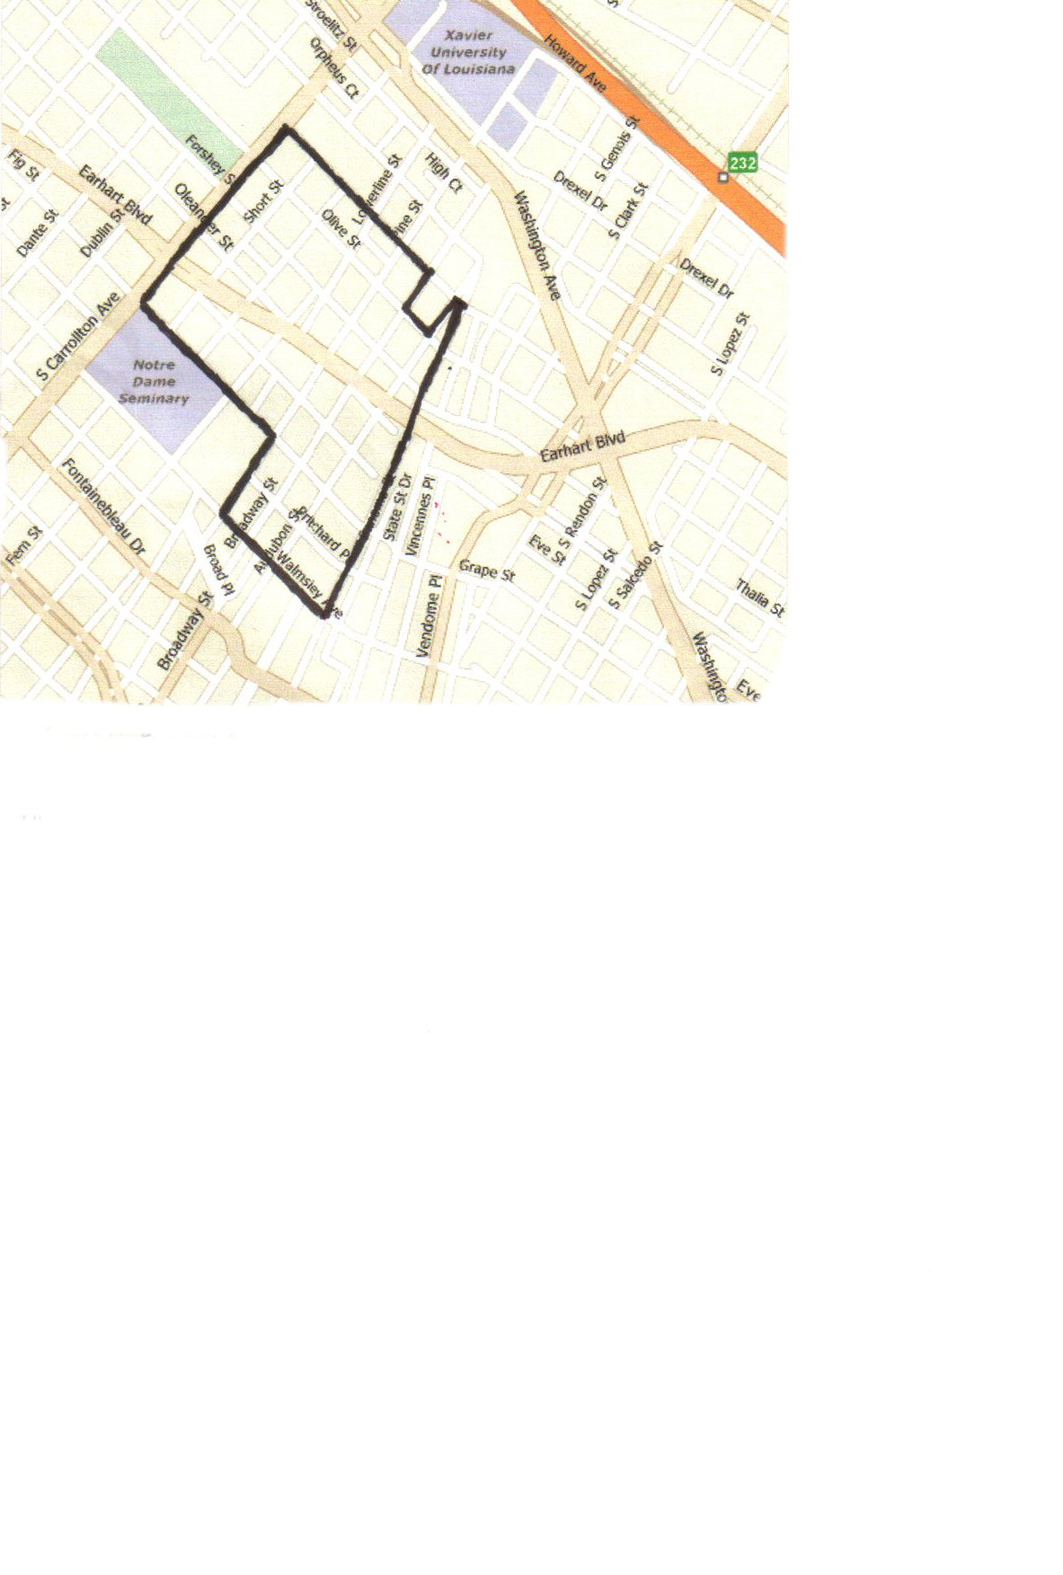

*Source: "Class Boundaries" as defined in Section 2.2 and 2.3 of the Supplemental Preliminary*